# Apply filters to SQL queries

## Project description

In this Portfolio example, we are going to filter out information utilizing AND, OR, and NOT conditions based on hypothetical examples. You may review the related document to see the full content of the tables.

## Retrieve after hours failed login attempts

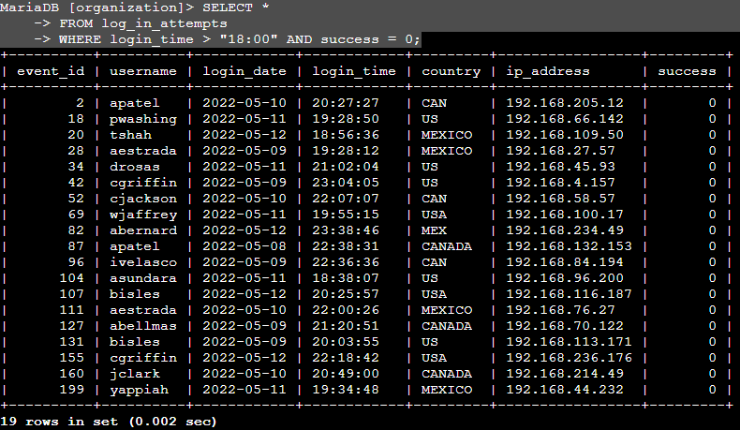

This query allows us to see the failed login attempts after work hours (work hours finish at 18:00). It’s a simple AND conditional statement which filters for two conditions. A failed login, and the fact that it happens after working hours.

## Retrieve login attempts on specific dates

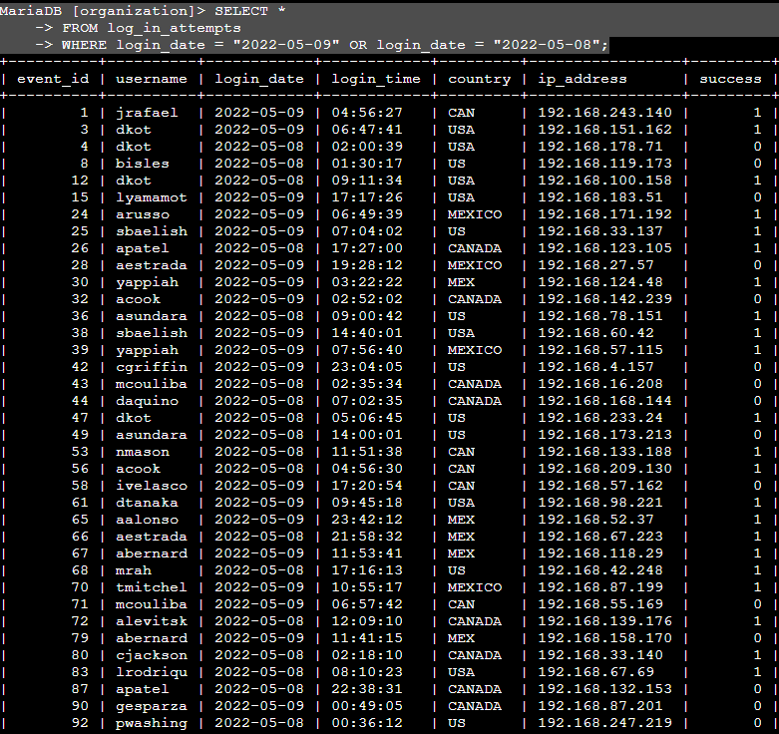

Next, we’re trying to find out login attempts over the day of the incident and the previous day, to see if there is a pattern we can define. For this, we use an OR clause in our query, in order to include results from both days.

## Retrieve login attempts outside of Mexico

We’re filtering out attempts from Mexico (referred to in the database as MEXICO or MEX) in order to focus on North America.

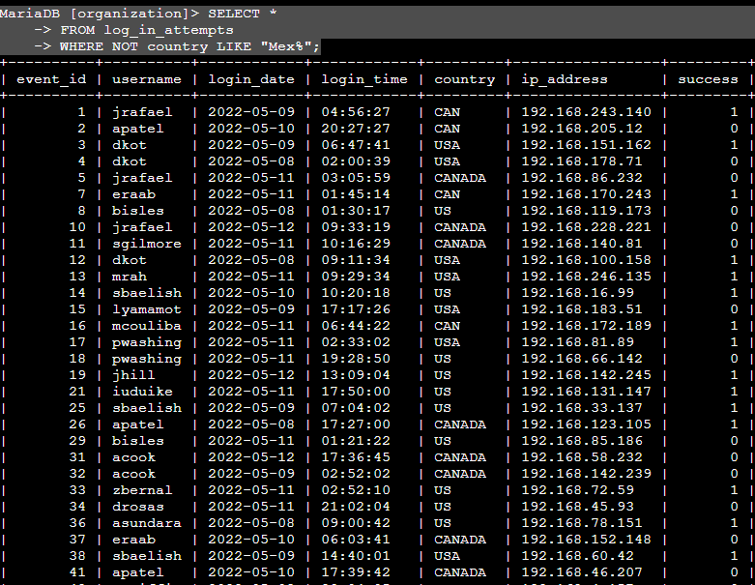

For this ,we use a NOT condition combined with a LIKE command to account for both ways of referring to Mexico.

## Retrieve employees in Marketing

Another AND example where we want to find out employees from the Marketing department in the East offices. As there are many East offices, we join the AND with a LIKE condition.

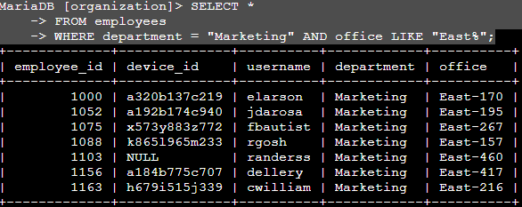

## Retrieve employees in Finance or Sales

Now, we’re searches for two different values in the same column. It’s an OR statement that has to be fully written out for both elements, even though they’re in the same column.

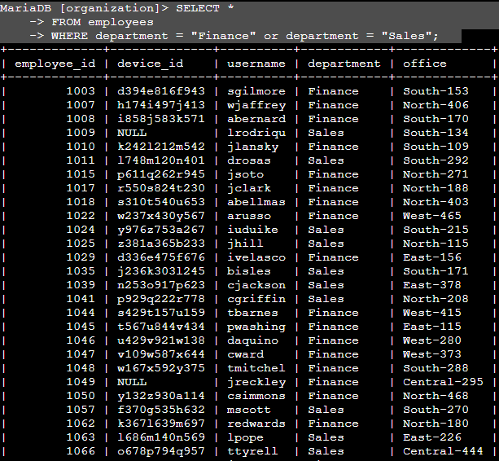

## Retrieve all employees not in IT

Finally, we are searching for all employees outside the Information Technology department. A simple example of a NOT statement.

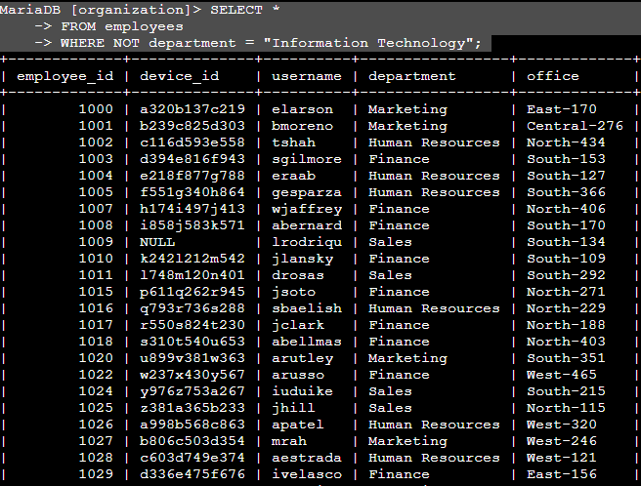

## Summary

As you can see, in this Portfolio example we have applies filters using the AND, OR, and NOT conditions to our queries and sometimes the LIKE condition. We have also mixed these conditionals together.